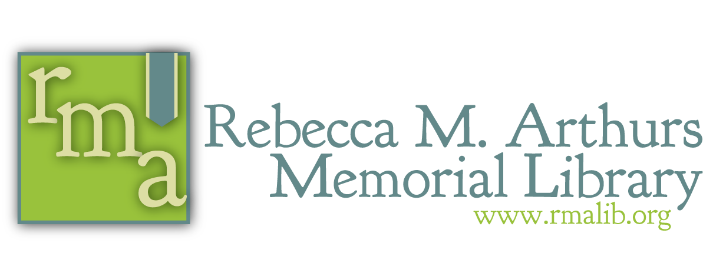
223 Valley Street – Brookville, PA 15825
814 849-5512 – www.rmalib.org

Information About Digital Library Resources

Please note: If you have a library card that doesn’t seem to work with digital resources, the account may need renewed/updated in our system (which can be done over the phone if you’re account is still registered in our system). If you have any questions about our library resources or if you’re experiencing any technical difficulties, please don’t hesitate to reach out by giving us a call, sending a private message to our Facebook page, or sending an e-mail to rmarthurlib@comcast.net.

------------------------------------------------------------------------------------------------------------------------------------------------------------
Once you have an active library account, you can search, reserve, and renew materials online by visiting rmalib.org and clicking on Library Catalog & Account. Log in with your library card number. Through the online account, you can also submit Interlibrary Loan requests by clicking on Book Request or view some of the latest additions to our collections by clicking Browse.
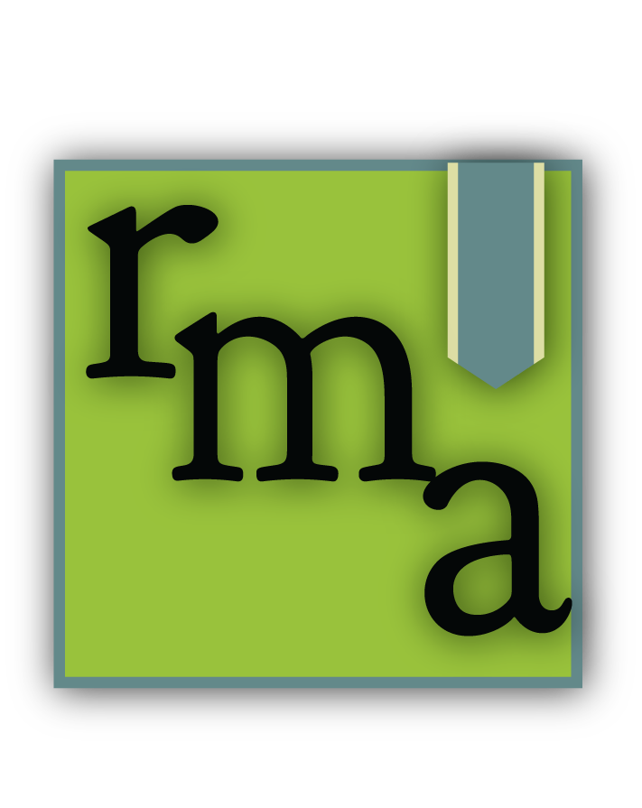

------------------------------------------------------------------------------------------------------------------------------------------------------------
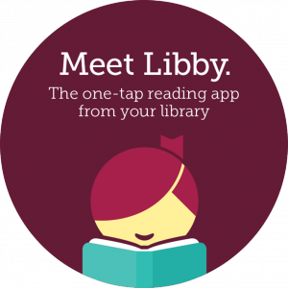
Libby by OverDrive offers a wonderful assortment of ebooks and digital audiobooks, which we share with other member libraries in the Oil Creek Library District. Prepare for your work commute, your next vacation, or even a weekend at home with a good book. Download the Libby app, search for Rebecca M Arthurs Memorial Library, and follow her user-friendly steps to access over 3,000 items!
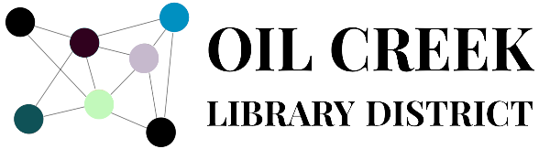
You can now borrow books from Seneca District Libraries to access a different set of ebooks and audiobooks.
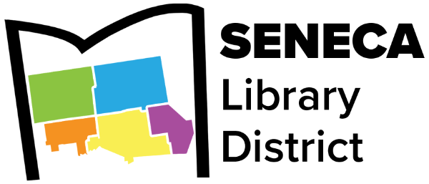
- For desktop users, visit oilcreek.overdrive.com and click on “Partner Libraries” at the top of the screen. Click “Sign In”, search for Rebecca M Arthurs Memorial Library, and enter your Rebecca M Arthurs Memorial Library card number.
- For mobile app users, you can add another library card under your Libby account. Search for “Seneca District Libraries” and click on “Visiting from Another Library”. Follow the sign-up instructions and use your Punxsutawney Memorial Library card number in the process.

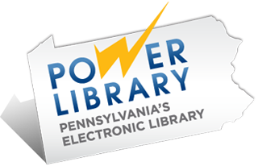
-------------------------------------------------------------------------------------------------------------------------------------------------------------------

Power Library offers numerous online resources with reliable, accurate information and covers topics in business, health, science, education, research and reference, and more. Look for the PA-shaped logo on our homepage at www.rmalib.org and use your library card number for access.

-------------------------------------------------------------------------------------------------------------------------------------------------------------------
Gale Courses Library cardholders can select from 350+ free Gale Courses to take online, on their schedule. Online courses are taught by professionals in the field, and topics range from business, financing, parenting, second languages, creating a website, graphic design, teaching, and so much more. Find the link on our homepage at www.rmalib.org.
- Browse the available courses.
- When you find one which you want to take, click "ENROLL NOW."
- Select your preferred start date and click "Continue Enrollment."
- Under "New Students Start Here", enter your email address and click "Create A New Account."
- Register using your name and information, and click "Create Account.
- You will need your library card number when prompted, so have it nearby.

Here’s a sample of other online resources available through Power Library and on our website at www.rmalib.org:

